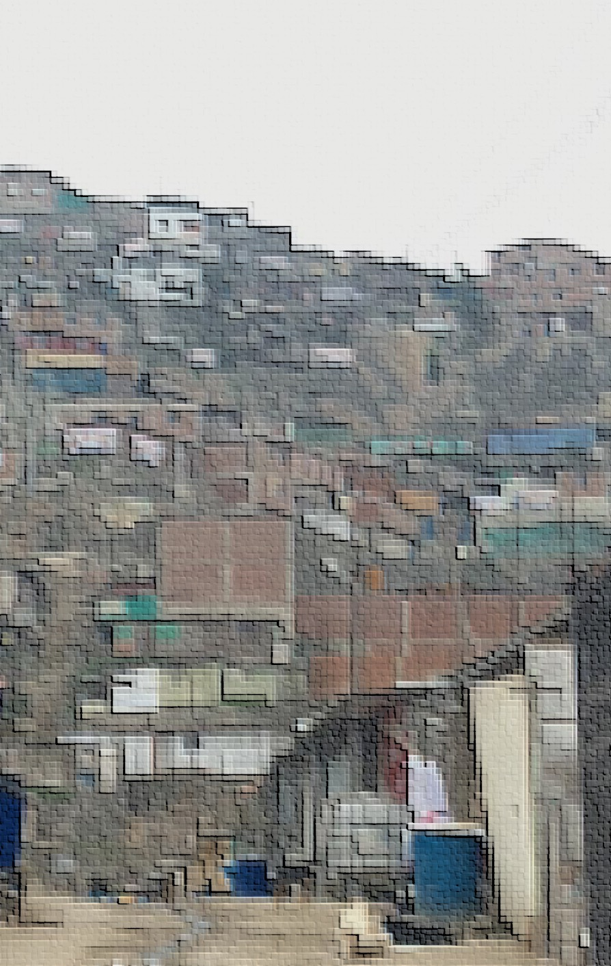Every year, in partnership with the Solidaridad en Marcha, Catholic churches throughout the city of Lima, Peru deliver thousands of Christmas gift boxes to the poorest residents in the city. The campaign, called La Caja Del Amor, has been in operation for years and has subsequently built long-term and well-sustained relationships with many community leaders in these areas.

The list of gift recipients is built in coordination with the local community leaders, most of whom oversee around 150 families. These leaders choose the 5 to 10 families in most need of assistance in their respective community to receive the gift boxes.

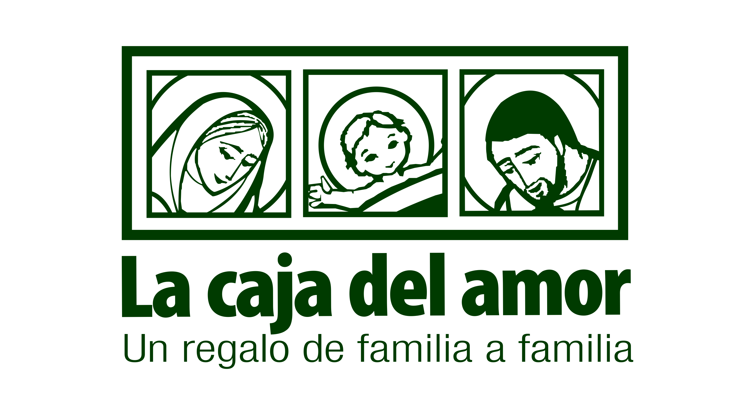

These networks served as a point of strength when we began to explore the creation of an in-depth survey to better understand the poorest urban populations in Peru. However, our focus needed to also be on action-ability of insight and the concrete opportunity of enacting positive change in the lives those we surveyed.

Therefore, we decided to focus on a region of high need, and an area where Solidaridad en Marcha had a significant footprint. This process of elimination led us to the region of Pamplona Alta near the San Juan de Miraflores municipality of Lima.

**Table of Contents**

**Pamplona Alta, A Brief History** 3

**Information Description** 5

* + Survey
  + Dataset

**Understand Population**  7

* + Averages
  + Distribution
  + Correlation

**Understand Groups Within Population** 13

* + Clusters
  + Communities

**Problem Discovery and Suggested Solution** 16

* + Household Size and Income
  + Role of Men
  + Grandparents, Children and Commuters
  + Newly Established Households
  + Females and Finance
  + Effects of Water Access

**Conclusion**

* + Summarized Solutions
  + Potential Impact

**Pamplona Alta**: A Brief History

Pamplona Alta is a shanty town riddled with extreme poverty, it has an absence of infrastructure, and a large portion of its community is without access to many basic human needs. The region has no public works, no paved roads, no public electricity, nor public access to water and sewage. If these services exist at all, they are provided by private companies at a premium price.

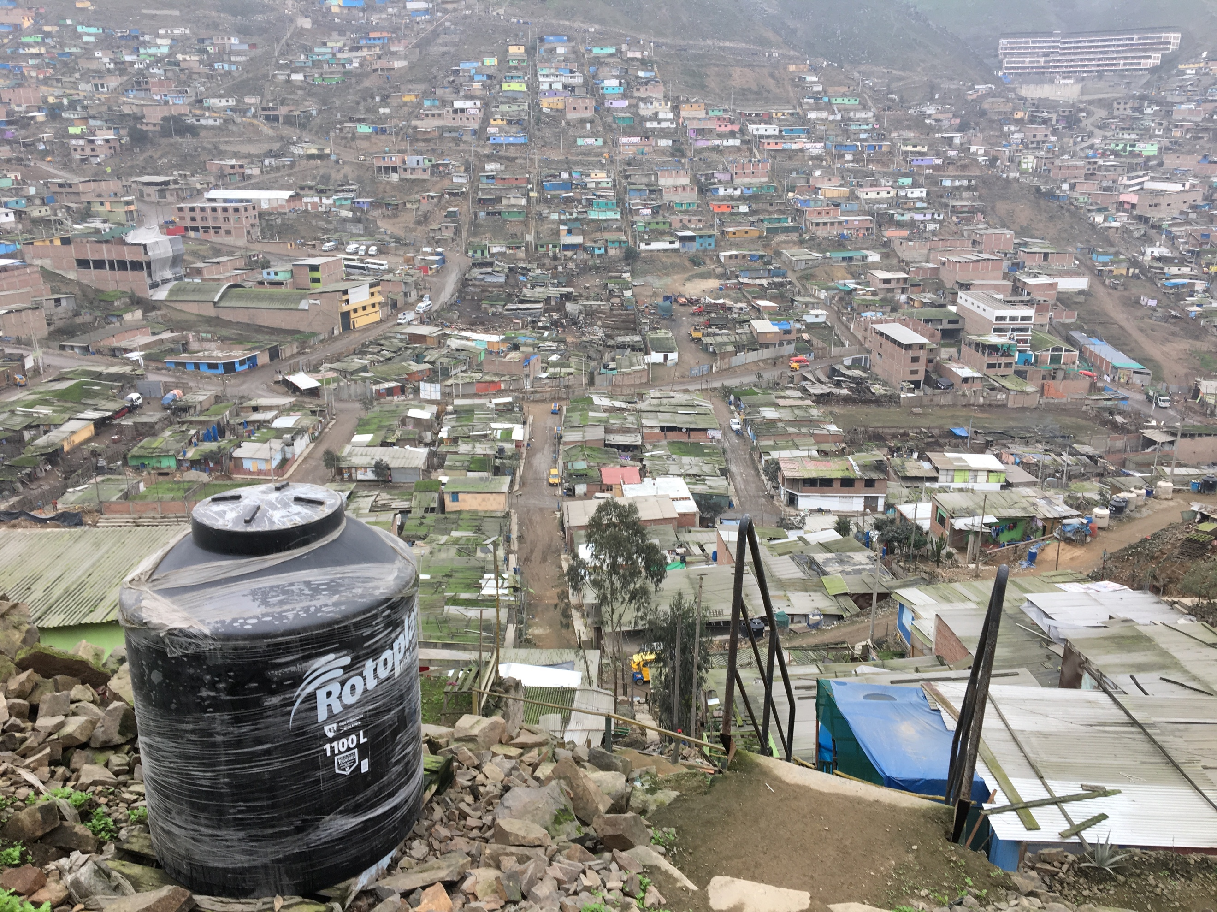Water trucks provide the only (non-drinkable) water and they often cannot access many of the homes, especially in the upper portions of the region. Shallow latrines serve as a poor substitute for sewage and along with the local pig farms, contribute to a high rate of parasitic infections, particularly among children.

The area was first populated in the 1990’s as a result of a decade of terrorism that affected the entire country of Peru. During that period, populations from the surrounding regions began a mass migration to the outskirts of Lima, leaving the lives they knew to find safety in the proximity of the city. Many only spoke Quechua, few had employment for years after arrival, and none of these new residents owned the land on the edge of Lima where they would now call home.

It has predominantly been this issue of land ownership that has ensured the continued impoverishment of the people of Pamplona Alta. Why land ownership? Well, owning the land is necessary, according to the government of Peru, for those in Pamplona Alta to receive basic municipal services. In order to attain roads, plumbing, water, schools and many other basic human needs, they must first own the land on which their homes sit.

The land is rocky, mountainous and un-arable, yet to the people of Pamplona Alta, it is home. Inside of this difficult landscape, there are two prevailing realities: those who squatted on public land and those who squatted on private land.

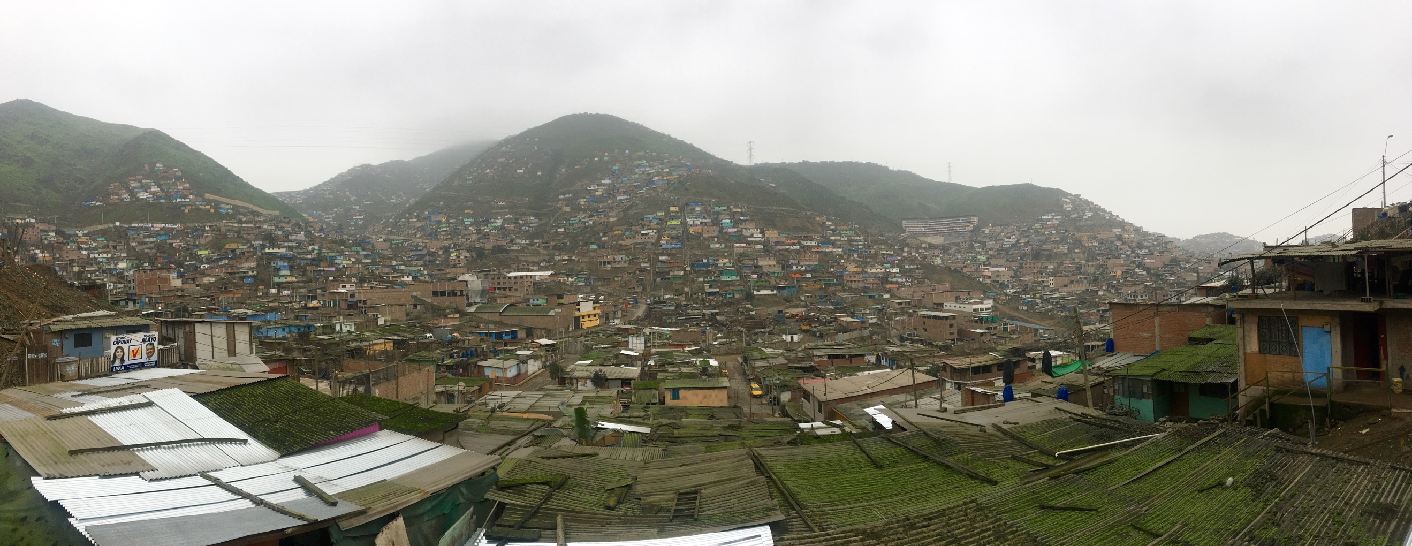

The valleys of this mountainous region were owned predominantly by pig farmers upon arrival, and even today many families live side by side to pigs in the lower part of Pamplona Alta. The owners of the land have lacked the resources to forcibly evict their unwanted tenants since their arrival, yet these tenants have now called Pamplona Alta home for over 20 years and despite their best hopes, still, have a nearly impossible chance of owning the land on which their homes sit. As a result, many of these structures lack stewardship, the inability to own does not reasonably warrant investment and in turn, the people there exist in squalor.

The story of those in the upper mountain portions of Pamplona Alta is a different, yet only a slightly less dire narrative. For people who have built their homes on government-owned land, ownership is possible, however, only after a laundry list of nearly impossible requirements, given by the government of Peru, is achieved. Land ownership is possible to those who squatted on government land if they have:

* been there for longer than 5 years
* access to water
* access to electricity
* safe access to home
* community centers/parks within close proximity of their house

In practice, the government of Peru is asking the poorest and least advantaged people in their country to not only sustain life on a few dollars a day, but also build a road to create access for a privately priced water truck to get to their home, to pay to bring privately priced electricity to their home, to build community centers and to construct safe access to their homes from the bottom of the mountain.

This task list is absolutely impossible on their own, and organizations like Solidaridad en Marcha have helped make home ownership a reality to some of the people of Pamplona Alta, however, this battle is still uphill, and full of rocks and mud.

It is important to keep in mind that, yes, the government has been far from perfect, however, they are also faced with an incredible dilemma. The government entities feel obligated to protect land rights, discourage further squatting on un-owned land and legally address how to approach a population of 350,000 people already living on land that is not their own. There are massive policy improvements that can be made, but there is no denying the incredible legal, economic and political complications involved.

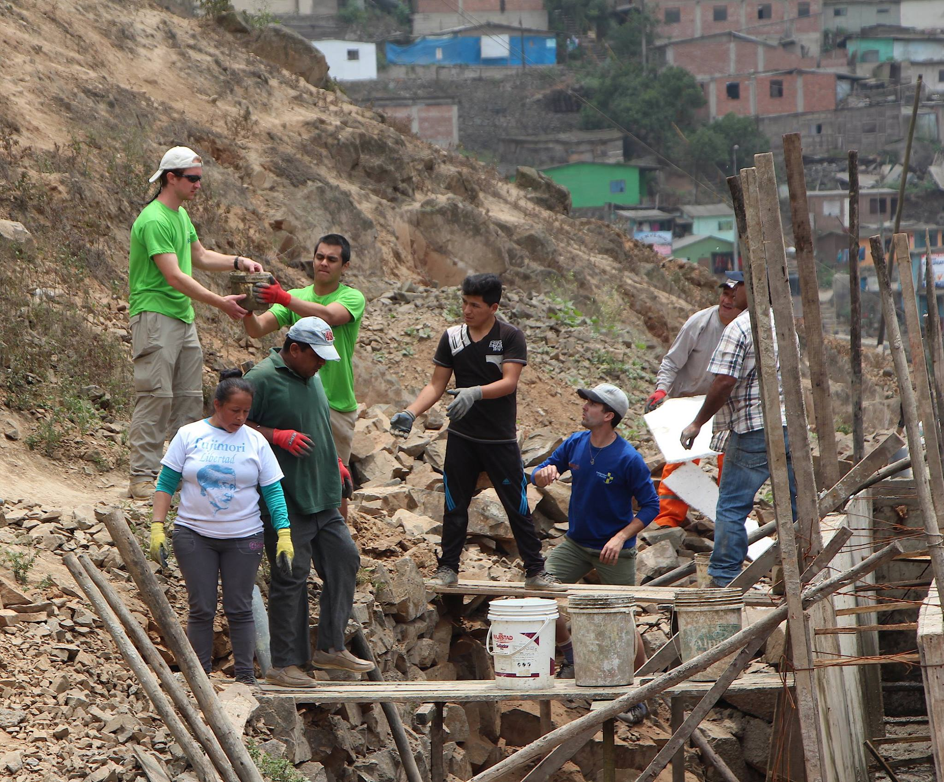

All things considered, the subsequent reality for the people of Pamplona Alta is that their children are frequently sick, their jobs are too far away, under-education is inevitable, many families are broken and the lack of government support ensures the existence of a dark economy, thus extending their lack of access to credit and upward mobility.

Deeper than these economic indicators of poverty, the people of Pamplona Alta suffer from the poverty of dignity. Many members refer to themselves as “the forgotten ones,” election promises come and go without much change and through the confusing red tape and legalities, they still find themselves without access to basic human needs. In spite of that, the people of Pamplona Alta are resilient, hard-working and deeply committed to building the best life they can for their families.

**Information Description**: Survey

Understanding the many facets of those in Pamplona Alta was integral in the way we built our survey, the questions we asked, and the way we asked them. We raised some questions that we heuristically had an intuitive idea of the answer, but needed to understand the severity. Yet, others we asked in order to gain insight into the tools we may have available to us within our solution set.

Lastly, we inquired of economic indicators, religious factors and family structure. All intended to paint a picture of the lives of those in Pamplona Alta and to possibly determine causality between the various characteristics.

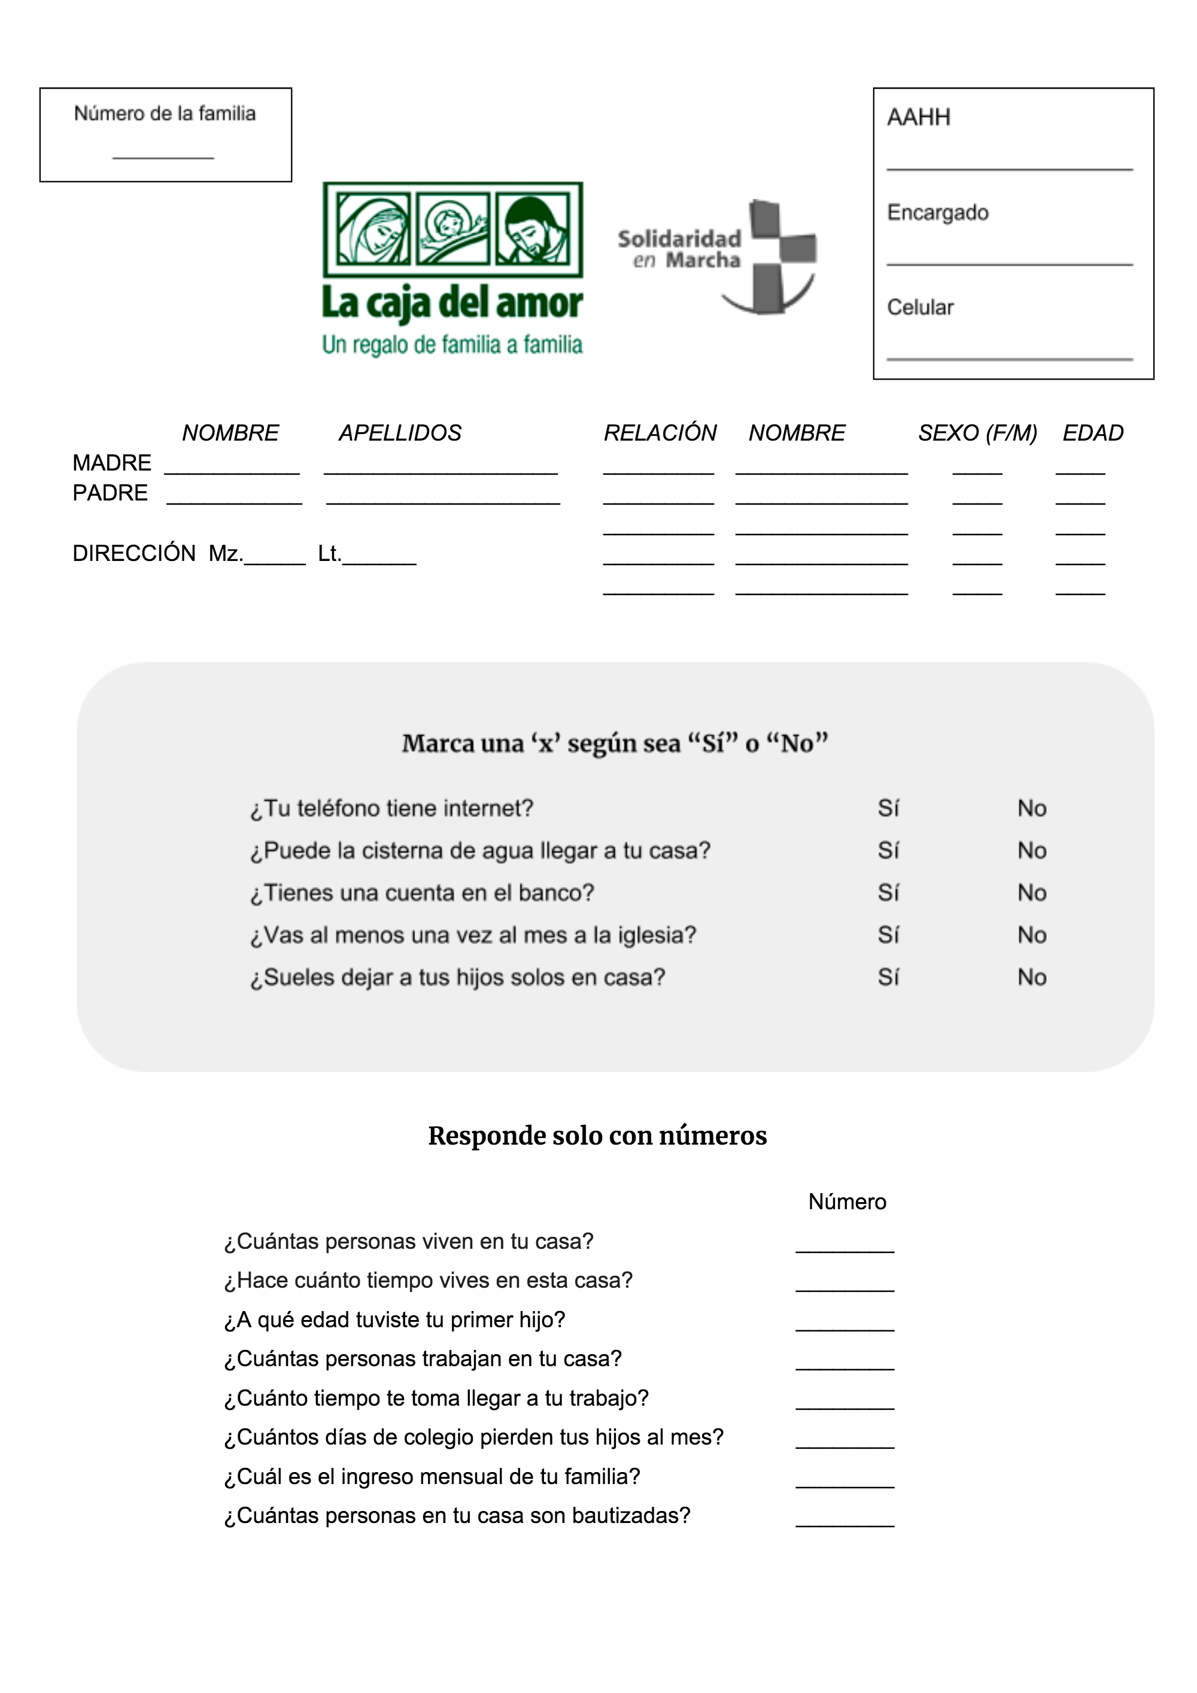

Using this form, we were able to fully survey over 500 families and after extracting all personably identifiable data, we built a dataset that held great potential for a greater understanding of the lives of those in Pamplona Alta and the possible routes available to help them.

**Information Description**: Dataset

Months of conversations, meetings, reading and collaboration with community members came into the building of this survey. Qualitative analysis helped us produce a dataset with the potential of performing multiple quantitative analyses.

The completed dataset built from the original survey contains 21 household characteristics (variables) of 507 families across 81 communities, providing information on a total of 2,231 people for us to explore, visualize and perform analysis on. The complete dataset can be found on my GitHub account, [here](https://github.com/showmalley/SeanOMalleyCodePortfolio/blob/master/Development%20Economics/PovertySurveys/CDA_FULL_2018.csv).

1. **fam_n** – *numeric* *factor* – Unique identifier for each family.
2. **internet** – *binary* – Does your phone have internet?
3. **agua** – *binary* – Can the water truck get to your house?
4. **banco** – *binary* – Do you have a bank account?
5. **iglesia** – *binary* – Do you go to church at least once a month?
6. **dejar_hijos** – *binary* – Do you leave your children home alone (when you go to work)?
7. **cuantas_personas** – *numeric* – How many people live in your house?
8. **tiempo_casa** – *numeric* – How long have you lived in your house?
9. **primer_hijo** – *numeric* – At what age did you have your first child?
10. **cuantas_trabajan** – *numeric* – How many people in your house work?
11. **tiempo_trabajan** – *numeric* – How long does it take to get to your job?
12. **pierden_colegio** – *numeric* – How many days a month do your children miss school?
13. **ingreso** – *numeric* – What is your monthly household income?
14. **bautizadas** – *numeric* – How many people in your family are baptized?
15. **direccion** – *character* *factor* – Name of neighborhood.
16. **padre** – *binary* – Does the father of the children live in the home?
17. **madre** – *binary* – Does the mother of the children live in the home?
18. **F** – *numeric* – Count of females in the home.
19. **M** – *numeric* – Count of males in the home.
20. **niños** – *numeric* – Count of children 18 and younger in the home.
21. **mayores** – *numeric* – Count of adults 65 and older in the home.

**Reminder:** I will at times use technical language, but I encourage you to keep reading through, because I will also accompany every technical insight with an explanation in simple language, relevant to the question at hand. Also note, for binary variables, 1 is yes and 0 is no.

**Understand Population:** Averages

We can see that a small proportion of those surveyed had bank accounts and internet access, while a large proportion went to church regularly and a majority had access to drinkable water though not overwhelmingly so. In terms of family dynamics, we see that only half of fathers are present in the home and most homes have a mother present. The initial pulse we get from the binary proportional averages is that we can affirm some of our pre-conceived ideas surrounding broken families and presence of a dark economy implying sparse routes to traditional credit sources.

|  |  |  |
| --- | --- | --- |
| Have Internet Access  11.06% | Have Access to Water  70.00% | Have Bank Accounts  3.89% |
| Attend Church Services  88.71% | Have Child Care  57.45% | Father Present in Home  54.82 % |

Inspecting the numeric means of our survey results, we can begin to get a sense of the lives lead by the poorest of the poor in Pamplona Alta. We see that the average time in the home is nearly triple the required 5-year requirement of the government for ownership. However, we also see that the average household of 5 is usually living off of the salary of a single person, and that average value is only 649 soles a month ($6.30 USD a day per household or $1.26 per person). Looking to the religious aspects of the survey, it is also interesting to note that on average only 2/5 members of households are baptized though a majority attend church services regularly.

|  |  |  |  |
| --- | --- | --- | --- |
| Household Size  5 people | Time in Home  14 years | Mother’s Age  at First Child  21 years old | Work Commute  1 hour 10 minutes |
| Working in House  1 to 2 people | School Missed  per Month  2 days | Household Income  per Month  649 Soles | Baptized in Household  3 people |
| Women in House  3 | Men in House  2 | Children in House  3 | Elderly in House  0 to 1 |

We do not want to make any extraneous assumptions from these average values, nevertheless, these initial figures have allowed us to paint a faint picture of the lives led by those surveyed and provided a question set for us to move forward in our analysis.

**Understand Population:** Distribution

Average values can give us a glimpse into the character of a variable, however, the distribution can tell us even more. Given the above results I wanted to take the time to look into certain variables of intrigue. This process gives shape to the values within, as well as helps us spot outliers that may have significantly affected our future modeling.

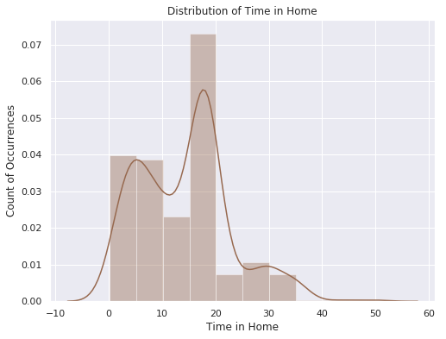

We can see that distribution of time-in-home is tri-modal, meaning that there are three time groupings in which people have been in their homes: many have been there less than 10 years, some more than 25, but most have been in their homes between 15-20 years. This is an encouraging data point when considering the government requirements for home-ownership.

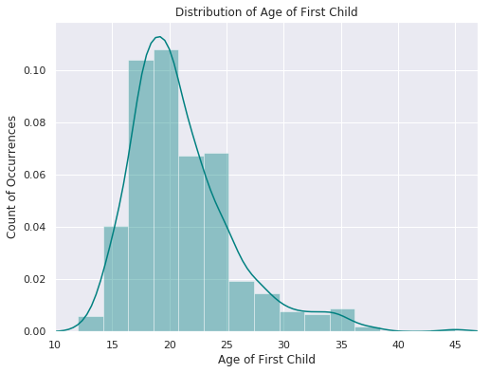The second distribution, is that of the first child. The average value for this number was 21, which given our knowledge of the region, felt higher than we had experienced. The distribution confirms the fact that a majority of the women are having their first child at or before the age of 20. The average value was being pulled upwards due to the positive skew of the distribution. In Pamplona Alta, the reality of having children before the age of 17 is often dropping out of primary school, so to see fewer of these than we anticipated is mildly encouraging.

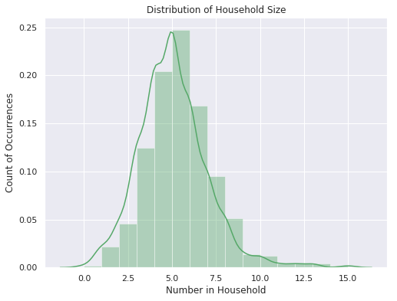

The third distribution of note is household size, the values are, more or less, normally distributed, with a majority of the households being between 4 and 6 people per household. We can see that there are some houses with as many as 15, but that number is small enough that those outliers should hold little weight to our predictive modeling further on.

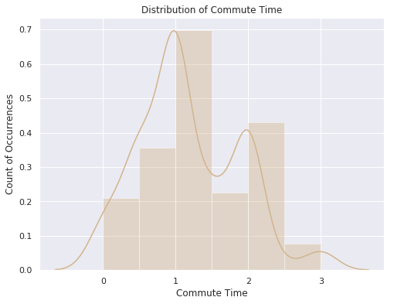

Next, looking to commute time, we see a mostly bi-modal distribution, with a majority of people traveling just over an hour to work, and another traveling over two hours to work. This confirms the difficulty we’ve seen for people in Pamplona Alta to find employment near to home.

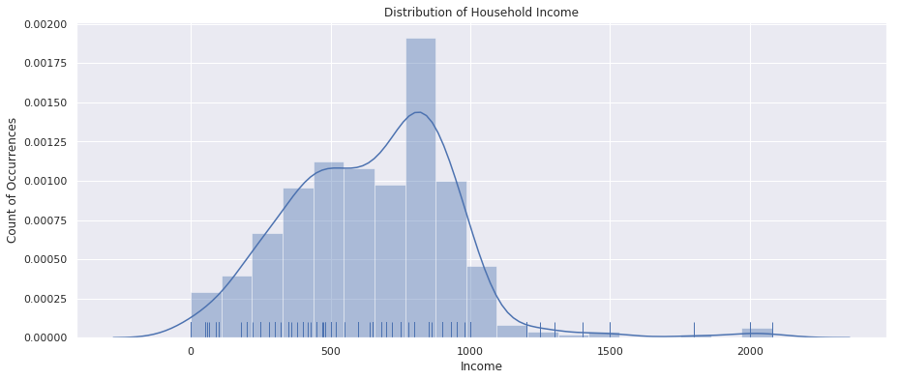When attending to the distribution of household income below, we need to keep in mind that we removed two outliers early in the exploratory process. Nevertheless, we see that a majority of the families surveyed had a household income between 500/S and 1000/S Soles per month ($147.84 to $295.68 USD). Most estimates for income per capita in Peru are mostly north of 1500/S per month, therefore we can affirm that our survey truly touched the poorest of the poor.

**Understand Population:** Correlation

Beyond univariate analysis, the study of only one variable, we want to start looking into how different factors behave in comparison to one another and to do so we will initially use correlation. Correlation is a mutual relationship, or connection between two or more characteristics/variables, therefore when comparing numeric relationships with correlation, the range is from -1 to +1.

If two variables are perfectly correlated, they will have a correlation of 1, while if they are perfectly opposite, they will have a correlation of -1. If there is no correlation, they will have a 0 value for correlation. In the chart below contains every variable we have available for comparison, and matching the values across the X axis with those on the Y, we can see the correlation value between those two values.

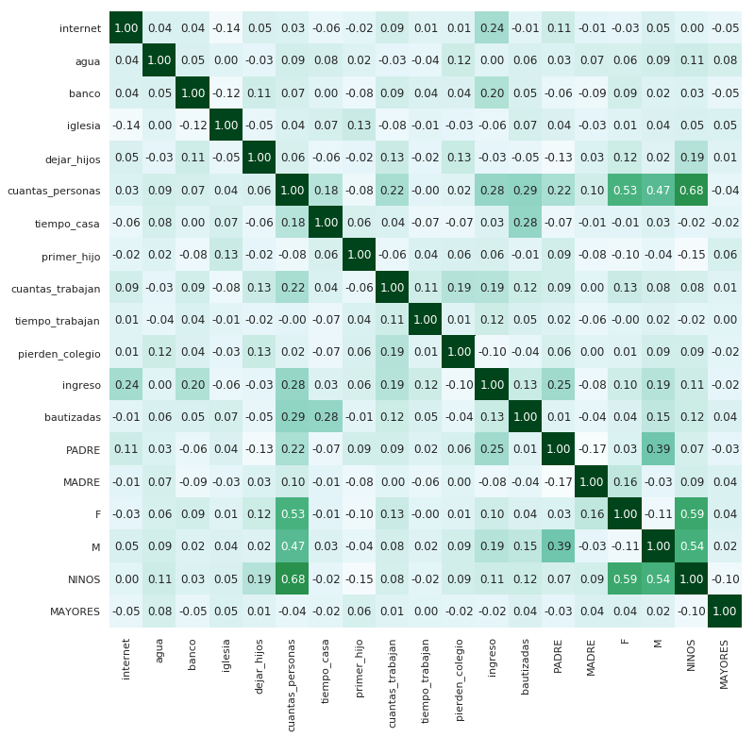

Initially, the correlation strengths are discouraging, we are seeing largely weak correlations between most of the variables, meaning that the predictive power of models we will build could be difficult to come by. However, we see some relationships with more than weak positive correlations, so let’s dig into a few of those:

* The more time someone has been in their house, the higher the likelihood that they will be baptized. Thus, implying those who are established in a community are also established more in the local church, while newly established / less stable families have a more difficult time attaining access to the sacraments.
* If the father of the household is present, there is not necessarily more workers in the house, but the household size and income are greater when he is present. What this could mean is that having a father present allows the family to make more money, thus the ability to support a larger household size.
* The relationship between internet and income is one of the stronger relationships, however the correlation does not mean causality. It is assumed that one needs money to pay for internet, however, it could be interesting to measure the causality of this relationship in order to see if access to internet also has the ability to propel the household income higher after attaining it. This is the same case for bank accounts, insofar as people with the most income have bank accounts, but with correlation we do not know if bank accounts are causing higher income; for this, other analysis will be needed.
* We see that the younger the mother was when she had her first child, the more children she ends up having in the household, also those who became mothers earlier are less likely to be involved in the local church.
* The larger the household size, the longer time in the house. This could just be a proxy for time, however, it could also suggest that the larger the family the more established they are in the community and all the subsequent externalities associated with that.

It is important to note the strength of these hypotheses are only as strong as the underlying correlations behind them, however the exercise above gives us an opportunity to move forward with some understanding and ask better questions as we go on.

**Understand Population Within:** Clusters

The survey delivered 21 characteristics about every household and using these characteristics, we have the potential to discover natural groups that exist within the total population. In order to bring these groups to light, we use what is called k-means cluster analysis. This technique places our 21 personal characteristics into a 21-dimensional vector space, and then determines centroids based on a given number of groups. In laymen’s terms, this means that k-means finds the people that are similar to one another.

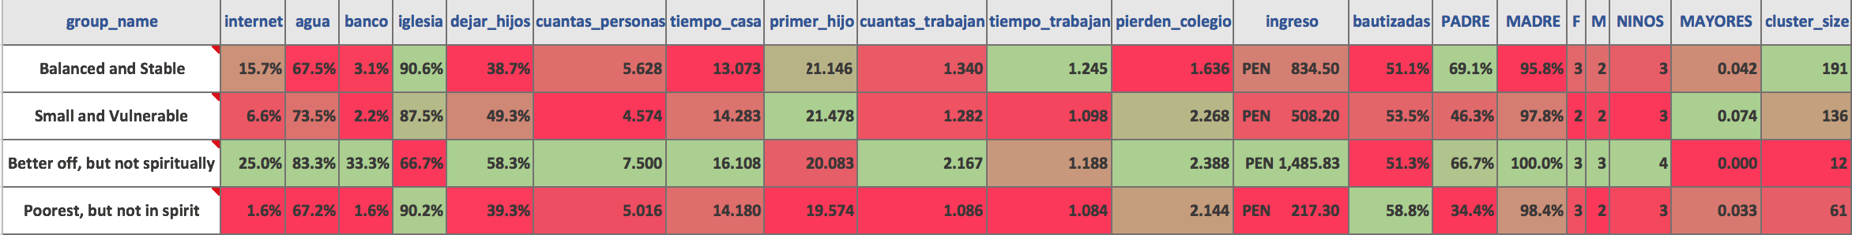Understanding what cluster (group) a household may fall into could help identify the optimal aid needs of that household as well as give shape to the community itself. We discovered 4 naturally occurring groups within the population and each, based off the average value of the characteristics of each group, we were able to discover a small story of the lives they lead.

**Group 1:** *Balanced and Stable*

* This group has the most balanced characteristics of those surveyed. 15% have internet, they have high rates of church attendance, but low rates of baptism. They have to travel far to work, but their households are more balanced, with a high rate of fathers in the home. They are the most likely to have grandparents in the household, thus leave their kids at home less, which quasai validates our thoughts on grandparents being great options for babysitters.

**Group 2:** *Small and Vulnerable*

* This group is interesting in that they are very similar to group 0, but earn far less, fathers are still in only 43% of homes, and all other postive statistics are muted by this. Their families are the smallest, but they also have the highest likelihood of having a grandparent in the household.

**Group 3:** *Better off, but not spiritually*

* Wealthiest group by far, with the highest rates of water, bank accounts, time in house. They had their first child later and have to travel farther to work. However, there is a spiritual gap with this group. We see that they have lower rates of baptism and go to church the least of all groups.

**Group 4:** *Poorest, but not in spirit*

* This group is the poorest among the groups, but has much higher baptism and church rates. Only 67% have water access 1.6% have bank accounts or internet. They do not leave their kids at home and they have short commutes to work. The only 34% of households have fathers and the families are smaller as a result. They are however established in the community and have been there for a longer period.

**Understand Population Within:** Communities

The survey reached 81 of the smaller communities within Pamplona Alta, and as discussed in the introductory story, we see that reality is largely varied amongst the communities within. In order to get a general idea of the state of communities, we have the average income by communities with more than 10 individuals. Similar to the income distribution charts, we can see that most communities have and an average household income between 600 and 800 soles a month. There is unfortunately a very poor set of communities that earn far less than 600 soles a month.

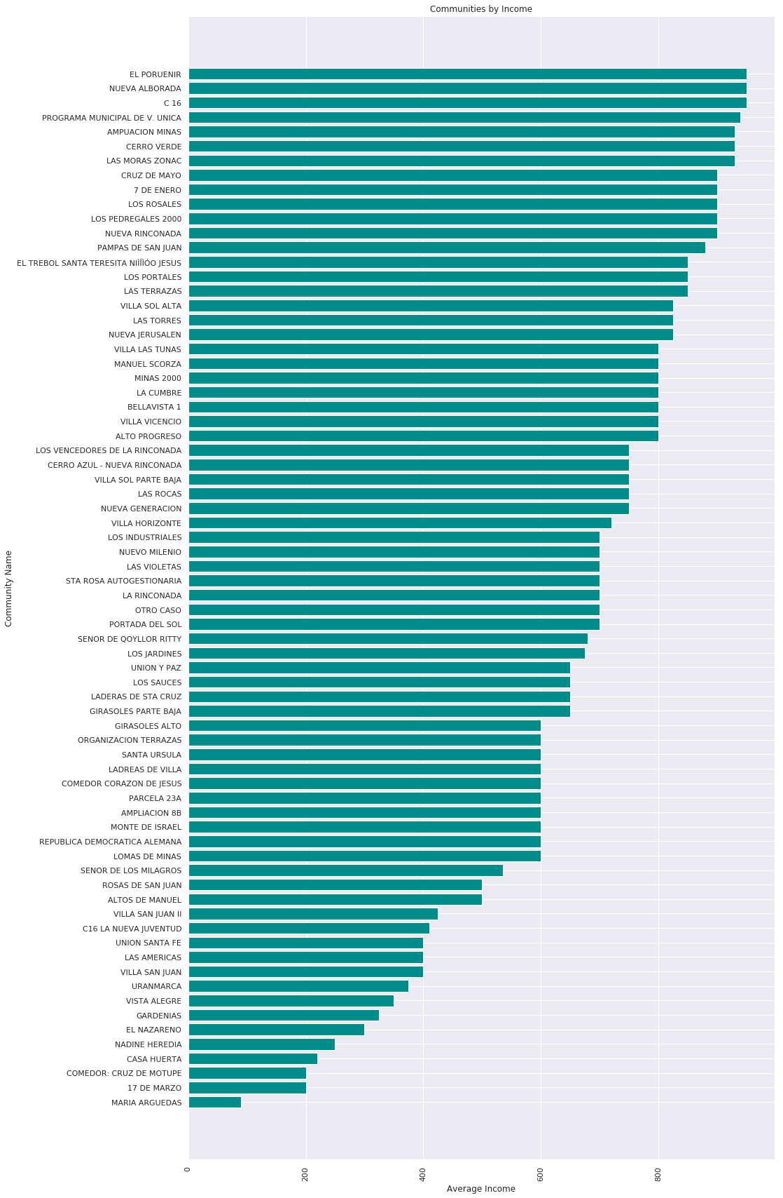

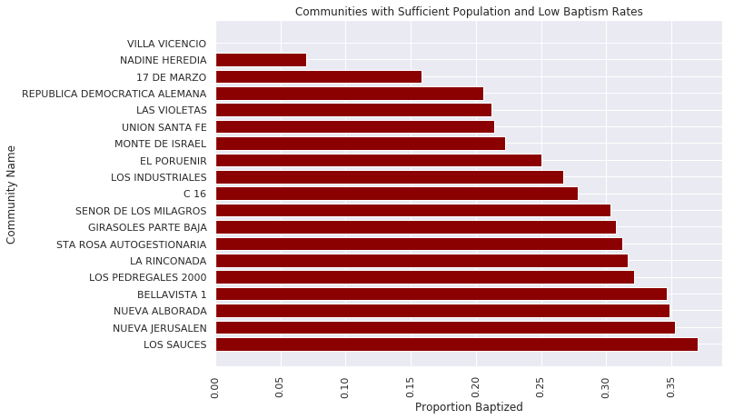

This graph displays the communities with the lowest quartile of baptism rates amongst all communities with more than 10 individuals represented. This list of communities could be given priority for catechesis efforts by various Catholic groups that come through.

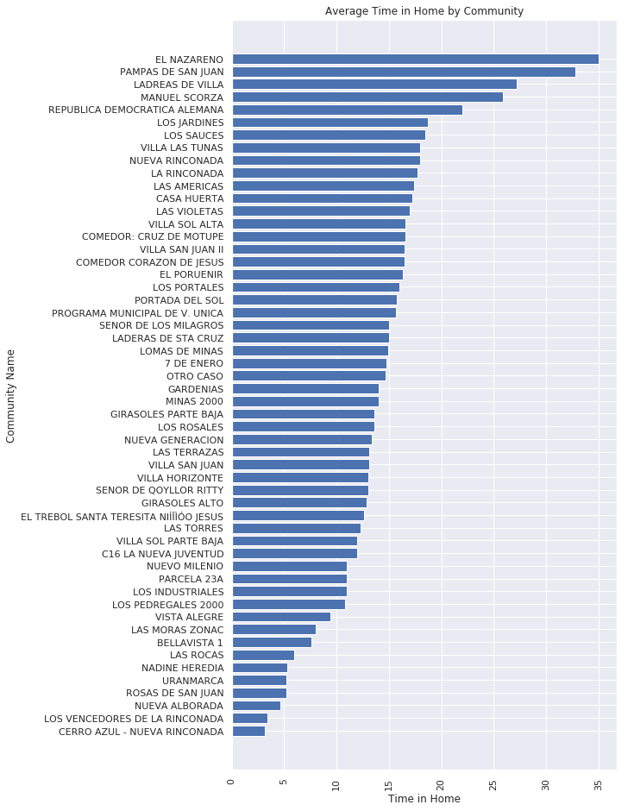

The time someone has been in their home is an incredibly powerful figure that impacts home ownership, community involvement, water access and general stability of a family. Given the nature in which families settle in Pamplona Alta, those communities whom have been in their home less, have access to less services, but are not particularly poorer (lower income) than other communities. This is evident when looking at the El Nazareno community, which has been in their homes the longest, but has one of the lowest average incomes amongst communities.

There are many questions that can be asked of metrics partitioned by community. We have given access to a raw csv of these averages and they are located [here](https://github.com/showmalley/SeanOMalleyCodePortfolio/blob/master/Development%20Economics/PovertySurveys/top_50_community_stats_by_size.csv).

**Understand and Find Solution:** Household Size and Income

The correlation gives us a high level understanding as to how two variables behave with one another, but the nature of that relationship is much deeper than correlation. Regression attempts to measure the relationship between a dependent variable and a predictor (independent). After, modeling multiple relationships using simple regression techniques, we determined the following points to be of significance to our understanding of the population:

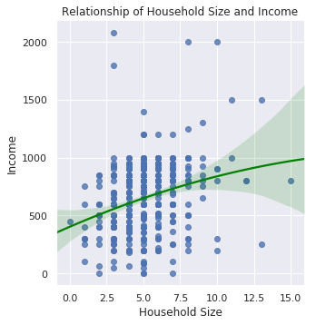

As the houshold size gets bigger, there is a slight increase in household income, however, this relationship begins to flatten out after a household size of 7. Thus, suggesting that families between 5 and 7 people, on the whole, have more financial stregth than those with small or very large families. In regards to aid work, it could mean that we need to give special attention to these big and small households.

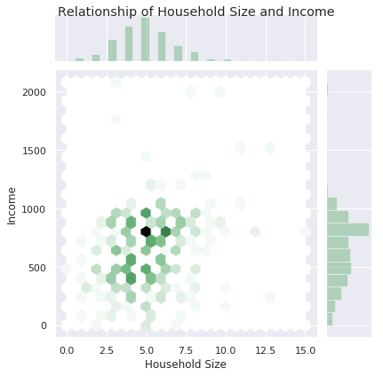

This visualization measures the same two variables as above, but instead of mapping a line representing the relationship, it visualizes density. We can see the densities along the right and top sides of the graph, and the hex shapes in the middle represent where these densities overlap. Therefore, what this graph is implying is that a majority of those surveyed have a household size of 5 with a household income of 780, offering us much more of a picture the the reality of this relationship.

**Discover, Understand and Find Solution** Role of Men

Coefficients of regression, charts and distributions

How do we help keep men in the household? Because they are better top-line earners and provide significant strength to the family income in a way that allows them to also support bigger families.

**Discover, Understand and Find Solution:** Grandparents, Children and Commuters

Coefficients of regression, charts and distributions

Provide support to families with multiple older family members

What are the largest obstacles faced by those with long commutes? How could we provide assistance to them in the way of childcare home support so they can go work better paying jobs in the city? What are those jobs? What skills do they require?

Could we provide a service to where one could serve the other here???? Without smartphone technology is the trick.

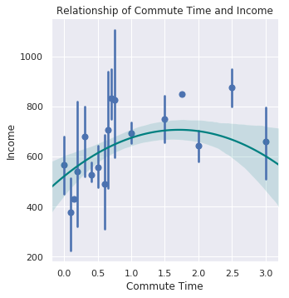

Commute time mapped with income can offer a glimpse into where the good jobs are at in relation to the slums. The graph suggests that the best jobs are 35 minutes to 2.5 hours away from their homes; and though there are many jobs nearby, none of them pay very well.

**Discover, Understand and Find Solution:** Females and Finance

Coefficients of regression, charts and distributions

Internet and bank accounts are massive indicators of increased wealth, and yes causality is not perfectly determined; however providing education on the usefulness of these resources with the correct connections; along with the psychological efffect of financial planning. Not to mention ending people working only in the dark economy; this gives us further leverage for the government helping people more in the shantytowns by proving their credit/societal worthiness.

**Discover, Understand and Find Solution:** Newly Established Households

Coefficients of regression, charts and distributions

New members to the community struggle to get to church, get baptized and attain water access more than other long term neighbors. Proiding services and introductions to these new members to the community could be really good in helping them get a leg up on their new lives in Pamplona.

**Discover, Understand and Find Solution:** Females and Finance

Coefficients of regression, charts and distributions

* Lack of water access on life factors
  + Water access decision tree

